**EXTRA PRACTICAL QUESTIONS (3 DEC 2020)**

1. **To display integer values of selected characters.**

**CODE:**

#include<iostream>

using namespace std;

int main()

{

char A='A';

char b='b';

char zero='0';

char eight='8';

char NL='\n';

char HT='\t';

char SP='_';

char BS='\b';

char Dollar='$';

char dblQuote='\"';

char oneQuote='\'';

char backSlash='\\';

char ruppee='₹';

cout<<"Value of ASCII character A is "<<int(A);

cout<<"\nValue of ASCII character b is "<<int(b);

cout<<"\nValue of ASCII character 0 is "<<int(0);

cout<<"\nValue of ASCII character 8 is "<<int(8);

cout<<"\nValue of ASCII character Newline is "<<int(NL);

cout<<"\nValue of ASCII character Horizontal Tab is "<<int(HT);

cout<<"\nValue of ASCII character Space is "<<int(SP);

cout<<"\nValue of ASCII character Backspace is "<<int(BS);

cout<<"\nValue of ASCII character Dollar is "<<int(Dollar);

cout<<"\nValue of ASCII character Double Quote is "<<int(dblQuote);

cout<<"\nValue of ASCII character One Quote is "<<int(oneQuote);

cout<<"\nValue of ASCII character Backslash is "<<int(backSlash);

cout<<"\nValue of ASCII character Ruppee is "<<int(ruppee)<<endl;

system("pause");

return 0;

}

**TERMINAL OUTPUT:**

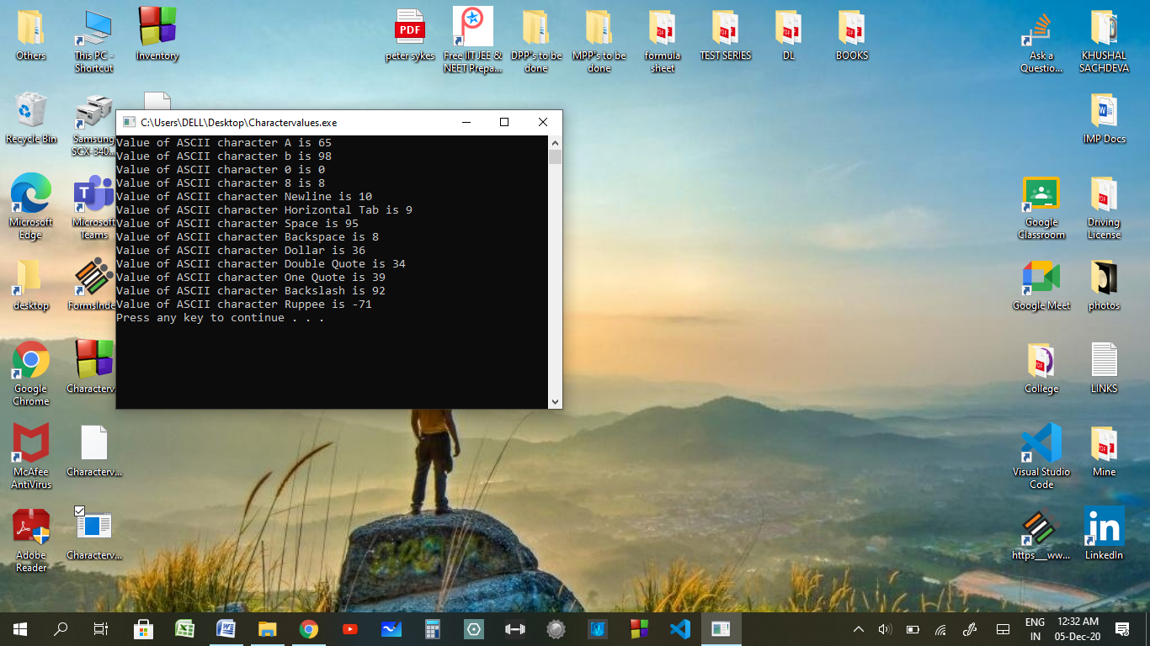

1. **To print the inventory report in given format.**

**CODE:**

#include<iostream>

#include<iomanip>

using namespace std;

int main()

{

cout<<"Part Number \t Qty On Hold \t Qty On Order \t Price "<<endl;

cout<<" "<<setfill('0')<<setw(6)<<31235<<"\t"<<setfill(' ')<<setw(15)<<22<<"\t"<<setfill(' ')<<setw(15)<<86<<"\t"<<setfill(' ')<<setw(10)<<"$"<<45.62<<endl;

cout<<" "<<setfill('0')<<setw(6)<<321<<"\t"<<setfill(' ')<<setw(15)<<55<<"\t"<<setfill(' ')<<setw(15)<<21<<"\t"<<setfill(' ')<<setw(10)<<"$"<<122.00<<endl;

cout<<" "<<setfill('0')<<setw(6)<<28764<<"\t"<<setfill(' ')<<setw(15)<<0<<"\t"<<setfill(' ')<<setw(15)<<24<<"\t"<<setfill(' ')<<setw(10)<<"$"<<0.75<<endl;

cout<<" "<<setfill('0')<<setw(6)<<3232<<"\t"<<setfill(' ')<<setw(15)<<12<<"\t"<<setfill(' ')<<setw(15)<<0<<"\t"<<setfill(' ')<<setw(10)<<"$"<<10.91<<endl;

system("pause");

return 0;

}

**TERMINAL OUTPUT:**

